Installing the ifolder Client
Very Important: Read directions very carefully as installing the iFolder Client correctly the first time will avoid further issues and complications.
To start the downloading process, go to this link: [Link]
- Navigate and click on the "iFolder Clients" link.
- Next, navigate and click on version "3.8.0.3".
- Depending on the Operating System: Navigate to and click on ifolder3-mac.dmg(mac) or ifolder3-windows.exe(windows).
Windows.exe Installation:
- You will be prompted to run, Click "Run".
- Next, the "iFolder 3 Client-InstallShield Wizard" window will pop up, Click "Next".
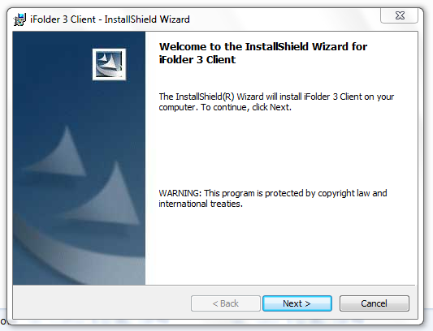

- Click the "I accept the terms in the license agreement" radio button.
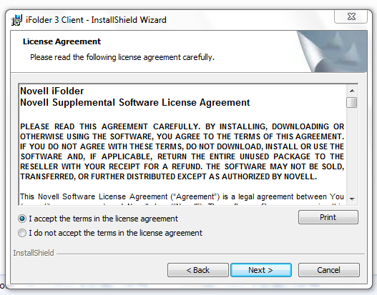

- Your Username and Password is already assigned, contact your iFolder Administrator if you need this information. Enter your user name (example: jdoe), type the organization (example: Microsoft), click the "Only for me (admin)" radio button, and click "Next".
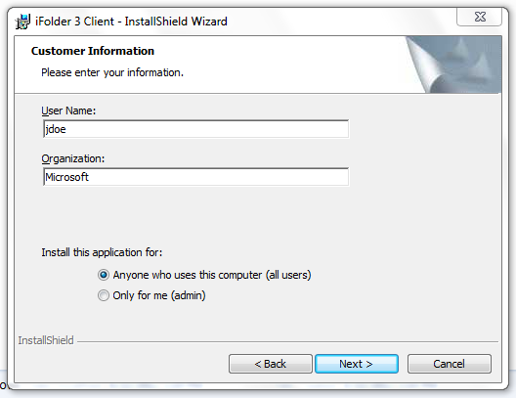

- Click "Next" on the "Destination Folder" section.
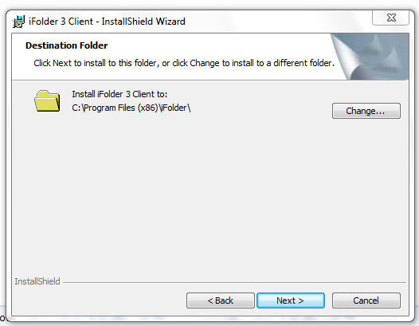

- On the "Ready to Install the Program" section, click "Install".
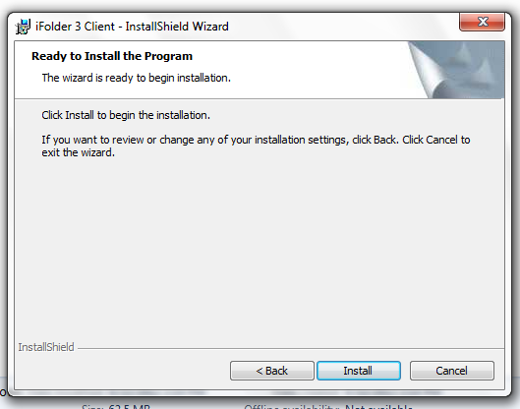

- Click "Finish" when the iFolder Client has completed downloading.
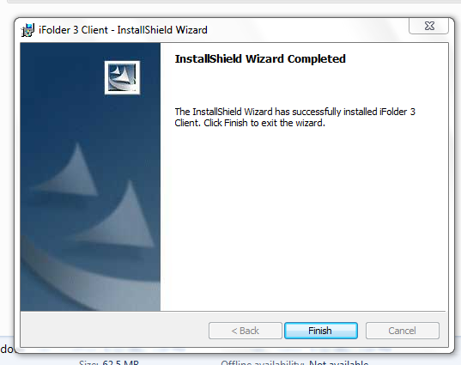
Note: You will be prompted to restart your computer once you have installed the iFolder Client, this must be done before continuing.
iFolder Setup:
Navigate to the iFolder program from the start menu.
- Click the iFolder program within the Start Menu > Programs > iFolder 3 Client.
- Click “Next” on the on the "Welcome to the iFolder Account Creation Wizard" page.
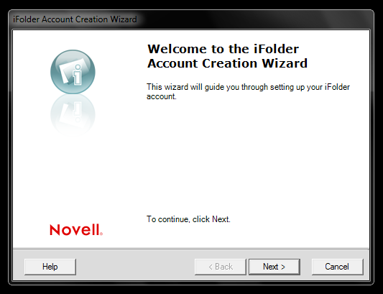
- Next, you will be prompted to enter the iFolder Server (for example: "ifolder.example.net")
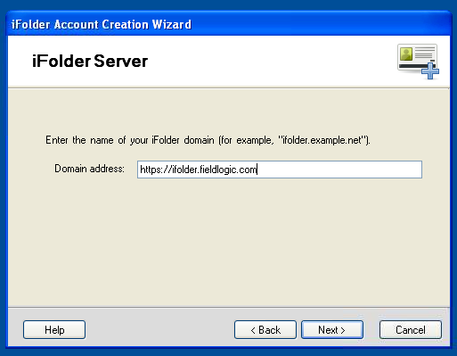
  - The server you will enter is: https://ifolder.fieldlogic.com
  - Click "Next"
- You will be prompted to enter your username and password (example: username: jdoe/ password:jdoe1)
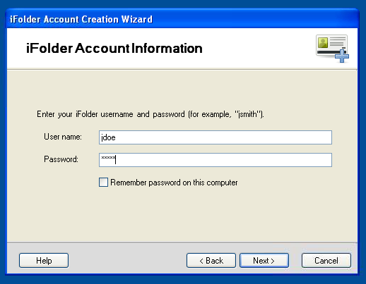
  - Your username and password should already be assigned.
  - Click "Next"
- The next page will be the "Verify and Connect" page.
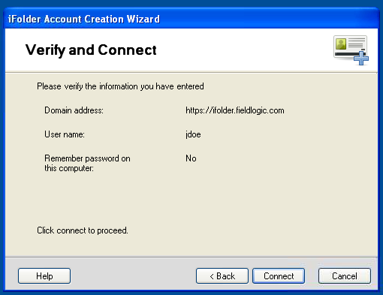
  - Look over the information to make sure that it is correct.
  - Click "Connect"
- Next, you will be asked if you would like to add a default folder, click "Next".
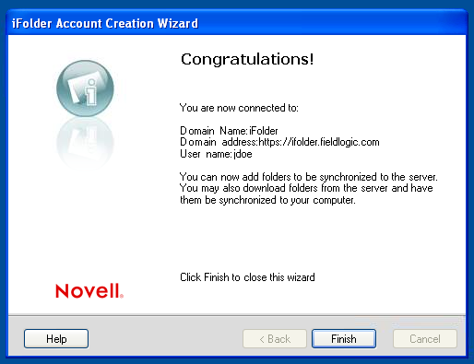
- Click “Finish”

iFolder Sync Files
- Go to your Desktop and create a folder called "ifolder".
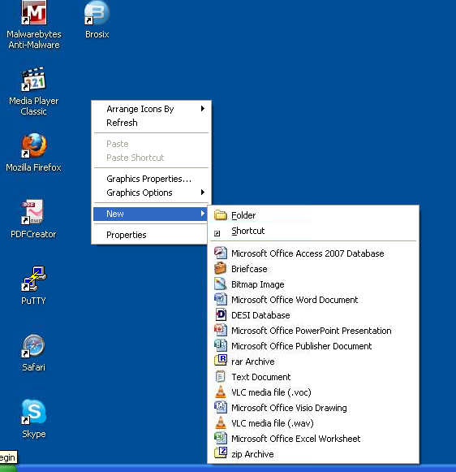
- Next, log into your ifolder client.
You will notice that there will be one or more folders in your ifolder client, you must sync these folders to the "ifolder" folder that you previously created on your desktop.
Note: If you see a 'Default_<username>' folder, ignore it, as this cannot be synced.
- Double click one of the folders located in your ifolder client (example: media kit).
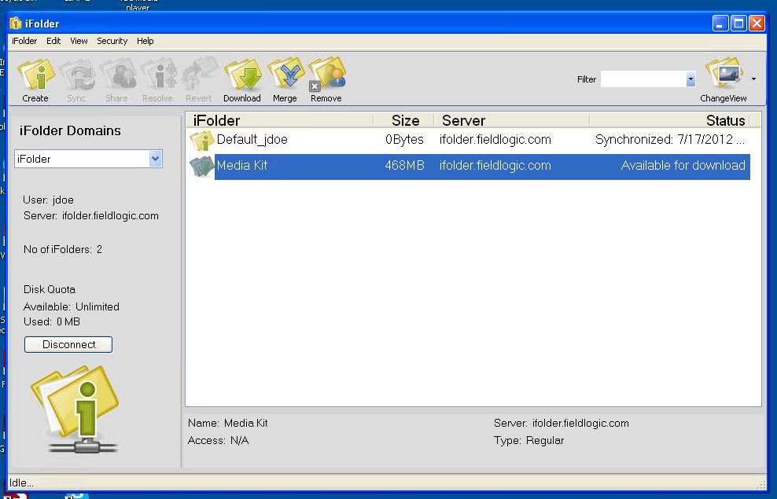
- A window will pop up with folder options. If necessary, click desktop to ensure that you are looking at your desktop files.
- Navigate to the "ifolder" folder, click on it, click "OK".
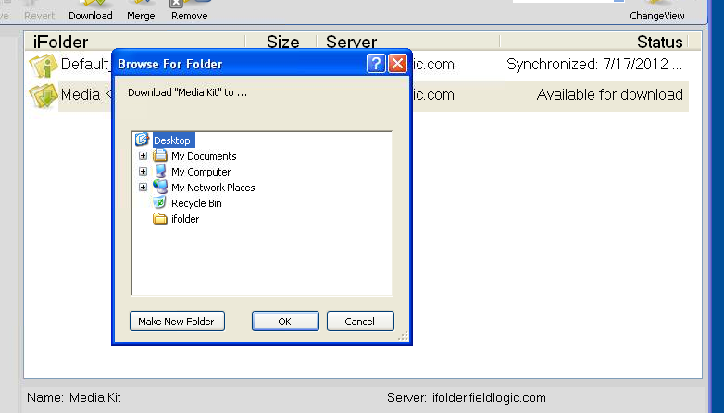
  - If you have additional folders that you would like to sync, follow the last three steps.

